User Manual

**Step 1:** Write number of Processes, Quantum Time, context switching time, and all needed detail of each process.

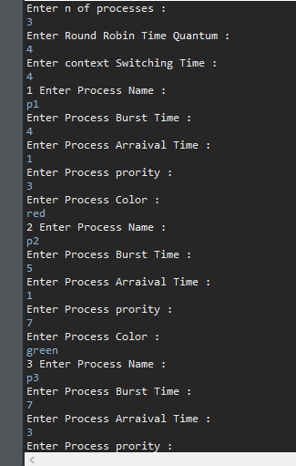

**Step 2:** this frame will pop up and represents the processing time and waiting time for each process

